Important Instructions for Completing a Complaint Form

Matters under the SEC supervision
- Matters under the SEC supervision in accordance with the governing laws. For example:
- approved securities / derivatives / digital asset intermediaries e.g.
securities company/broker, asset management company and digital asset exchange;
- approved persons e.g. investment consultant;
- listed companies/ securities issuance e.g. prospectus/financial statements/annual report;
- inappropriate behaviors of executives or directors e.g. embezzlement of company assets/ window dressing.
- Complaints with sufficient details or evidence for submitting a complaint.
- Complaints that are not related to day-to-day operation, for instance, business judgment, issues relating to staff or internal operation.
- Complaints that are not barred by prescription or limited by time to gather evidence as specified by law.
Matters beyond the SEC responsibility
- Matters under supervision of other laws, for instance, Ponzi scheme, poor services or poor product quality, advertising blockage on sidewalks, poor construction quality, incorrect information provided by insurance companies / brokers, or unfair credit consideration.
- Complaints under the process of the court’s consideration or cases having reached final judgments.
- Repeated complaints of the same matters that have already been clarified by the SEC, without new information or additional supporting evidence.
- Claim for damages or compensation or private and business disputes.
- Complaints barred by prescription or limited by time to gather evidence as specified by law.

For More Information, please contact SEC Public Service Center
Tel. 1207 press 2 e-mail : complaint@sec.or.th
The Office of the Securities and Exchange Commission (SEC Office) emphasizes the importance of personal data protection and respects your right to privacy. Please read the SEC Office’s Privacy Policy carefully via this link: (https://market.sec.or.th/DATAPRIVACY/E05-POLICY-INTERNAL-WEB.HTML). The SEC Office will only process your personal data to provide details and actions related to complaint handling or information inquiry services under legal basis - Public Task.
(This part is not for submission)

Complaint Form

Explicit information and complete evidence provided will be beneficial to resolving your complaint.
The SEC may have to disclose complainant’s information to related parties e.g. individual or entity you have a complaint against as well as other agencies for completion of complaint consideration procedure.

- Complainant’s information
Name : Mr. Mrs. Ms. ……………………………… Surname : …………………………………
ID number/Passport ID : ……………………...…………………………..…………………………………
Gender : Male Female Aged : ………………….. Nationality : …………………………………..
Email : ……………………………………………………………………………………………………….
Telephone No. : ………………………… Mobile No. : ……………………… Fax : ……………..……….
Address : …………………………………………………………………………..………………………....
……………………………………………………………………………………………….……….………
……………………………………………………………………………………………………….…….…
- Information about individual or entity you have a complaint against
Name : Juristic person Ordinary person
……………………………………………………………………………………………………….………
Objective of the complaint wished to be accomplished : ……………………………………………………………...………………………………………………………………………………………………………………..…………………………………………………………………………………………………………………………………………………………………..
- Complaint’s Nature (please tick main topic and subtopic you wish to make a complaint, provided that you can tick more than 1 topic.)
Unfair practice:
Taking advantage of inside information
Share price Manipulation
Dissemination of false statements or any other statement with the intention to mislead other persons
Dissemination of news with potential impact on share price movements
Dissemination of false news
Issuance and offering of securities for sale:
Initial Public Offering - IPO
Public Offering - PO
Private Placement - PP
Rights Offering –RO
Others, please specify ……………………………………………………………………….
Listed companies:
Inaccurate/insufficient disclosed information
Unfair allocation of shares
Executives/directors committing dishonest acts
Others, please specify…………………………………………………………………………
Securities company/asset management company/mutual fund:
Inaccurate/insufficient disclosed information
Inefficient workflow
Others, please specify…………………………………………………………………………
Investment Consultant:
Conducting personal trades through the clients' accounts and the trades cause loss to the account holder
Failing to comply with a client’s instruction
Solicitation to purchase securities causing a loss of money
Others, please specify…………………………………………………………………………
Others, please specify: ………………………………………………………………………………..
………………………………………………………………………………………………………….
………………………………………………………………………………………………………….

- Complaints that Complainant has taken
Never complain this matter to the SEC
Have complained this matter to the SEC on date….../….../…... could not remember
have never been responded
have been responded
Have complained this matter to other agencies including ………………………………………………

- Complaint’s details

……………………………………………………………………………………………………………..
……………………………………………………………………………………………………………..
……………………………………………………………………………………………………………..
……………………………………………………………………………………………………………..
……………………………………………………………………………………………………………..
……………………………………………………………………………………………………………..
……………………………………………………………………………………………………………..
……………………………………………………………………………………………………………..
……………………………………………………………………………………………………………..
……………………………………………………………………………………………………………..
……………………………………………………………………………………………………………..
……………………………………………………………………………………………………………..
……………………………………………………………………………………………………………..
……………………………………………………………………………………………………………..
……………………………………………………………………………………………………………..
……….……………………...
( )
complainant Date ….../….../…...

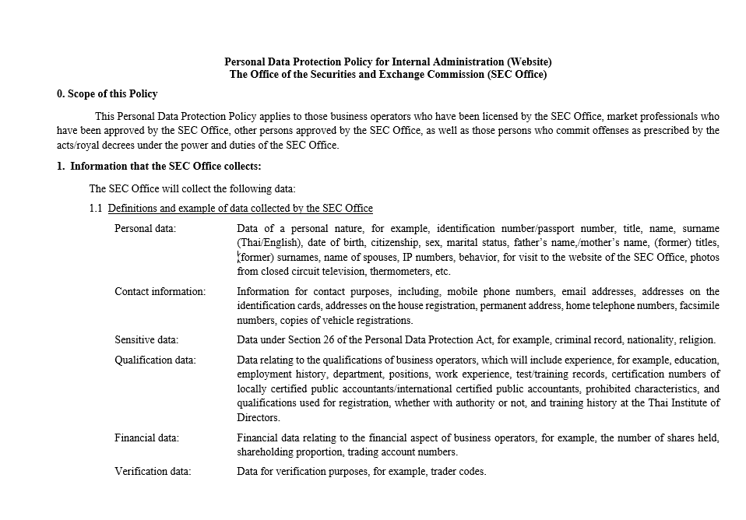
(This part is not for submission)
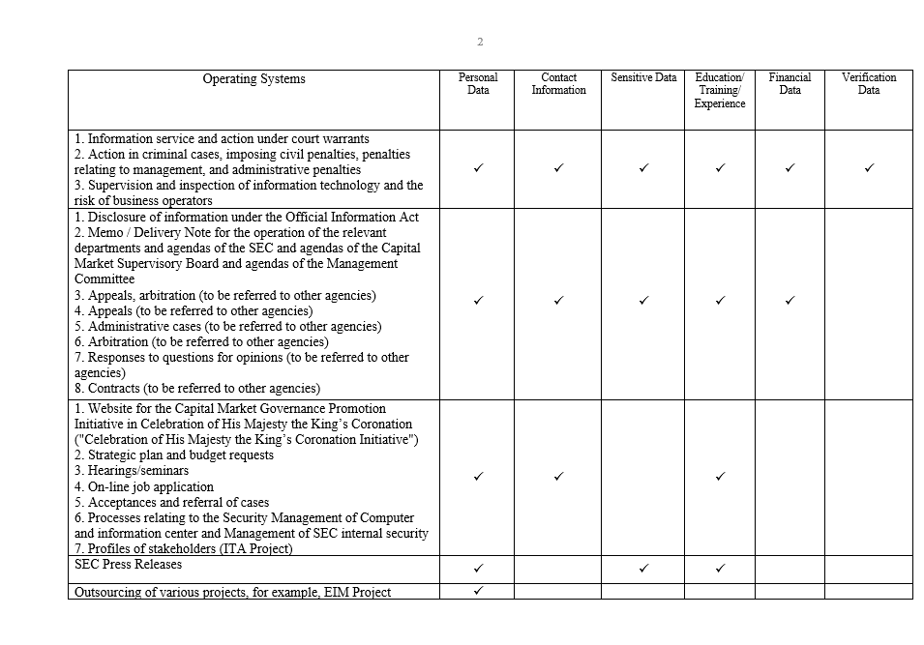
(This part is not for submission)
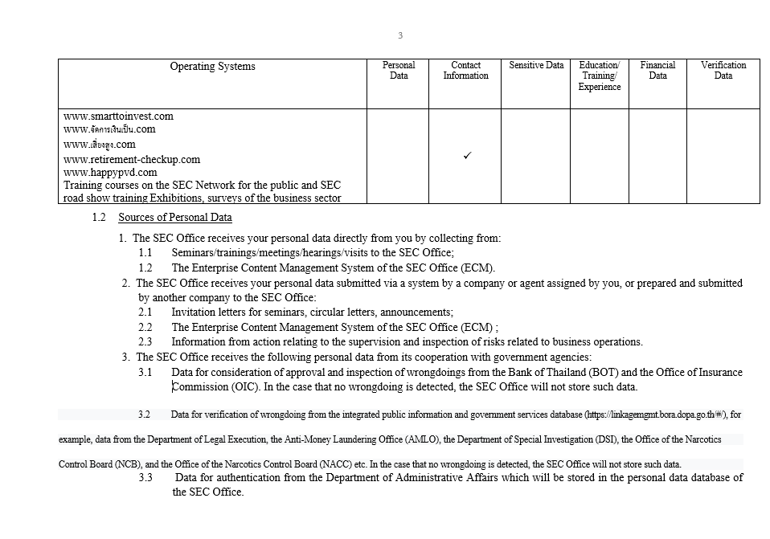
(This part is not for submission)
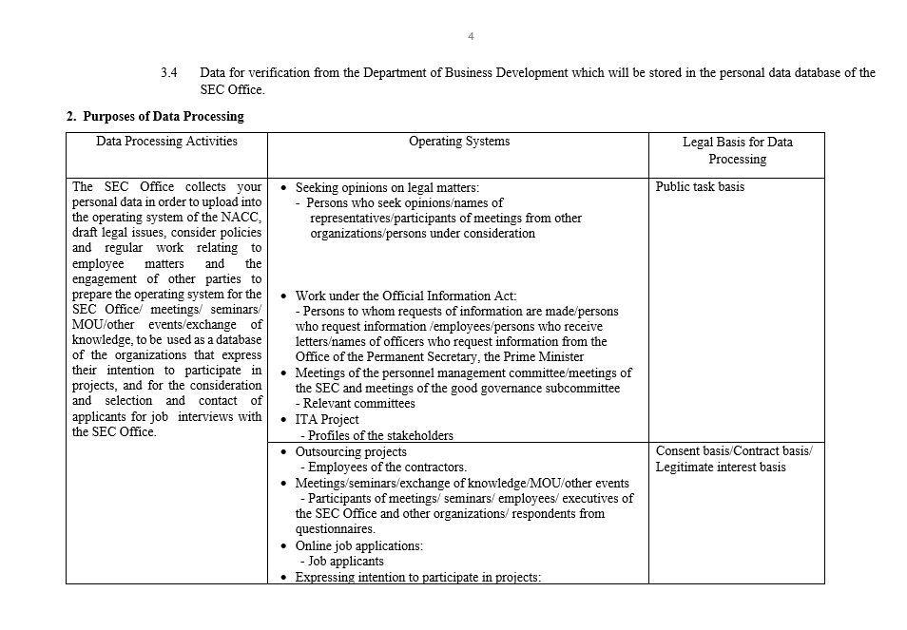
(This part is not for submission)
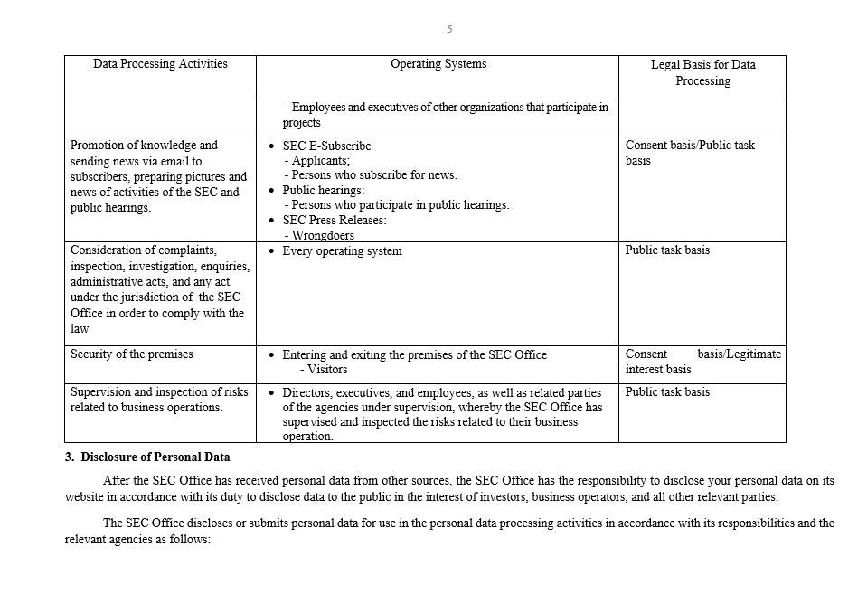
(This part is not for submission)
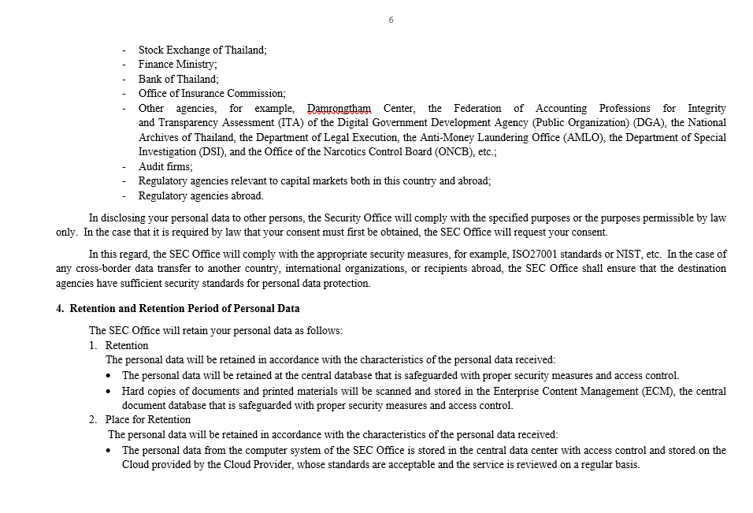
(This part is not for submission)
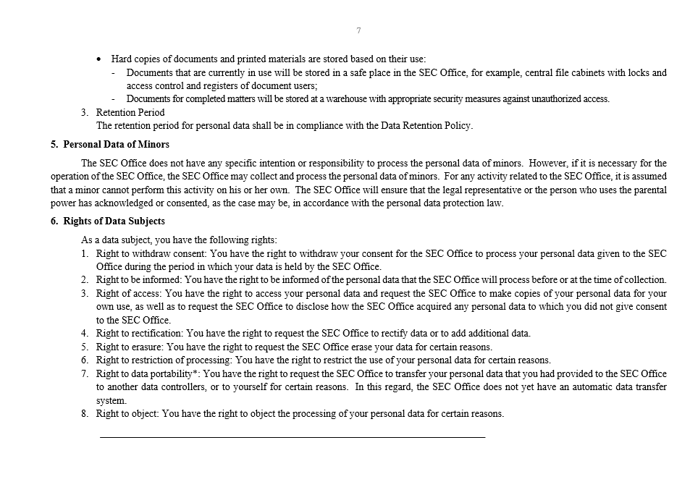
(This part is not for submission)
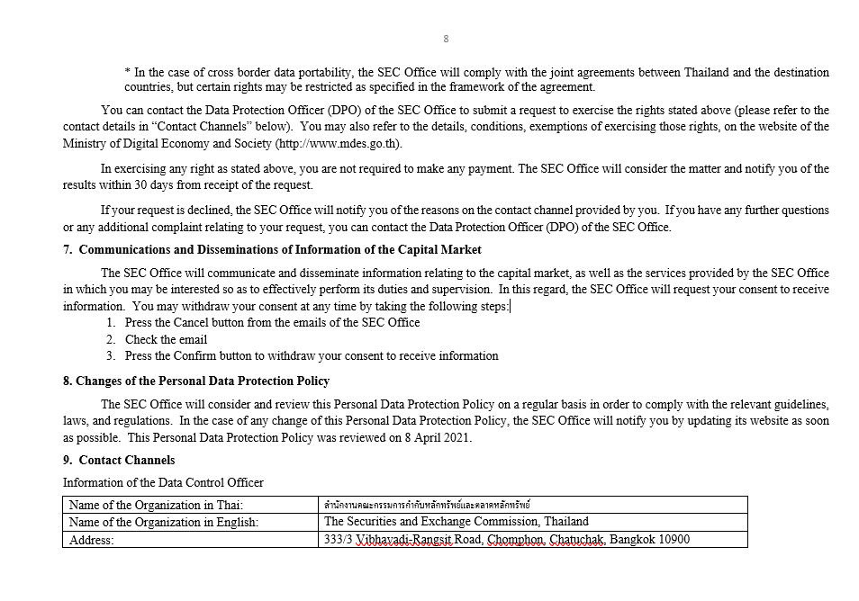
(This part is not for submission)
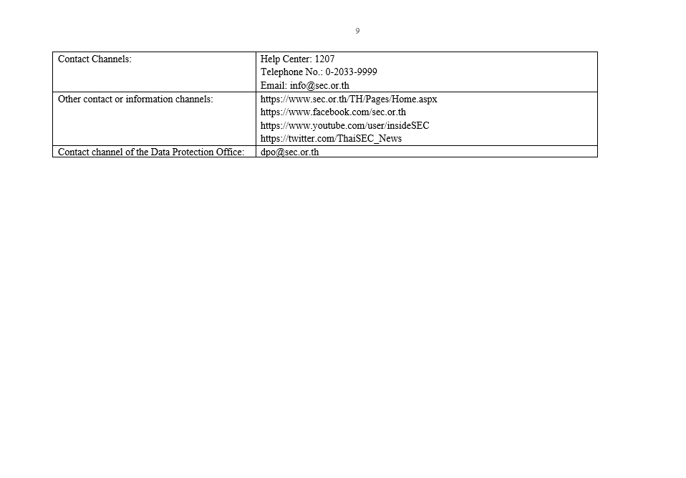
(This part is not for submission)

